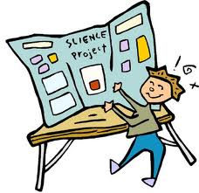
Science Fair Project Checklist:

______ 1. QUESTION: Determine the question you want to answer. It must compare 2+ things or products.

______ 2. PURPOSE: Tell why you are doing this project. Why are you interested in this topic? Why did you choose this experiment?

______ 3. RESEARCH: Find out more about your topic, such as information about each item/product you are comparing (use web/book research, surveys, interviews, phone calls to companies, etc.)

______ 4. HYPOTHESIS: What do you think will be the conclusion? What do you predict (or guess) will happen as you investigate you question? Why do you think this?

______ 5. MATERIALS: Write down all the materials you will be using.

______ 6. PROCEDURE: Determine the steps you will take to complete your investigation. List the steps and describe clearly what you will do. Make sure your experiment can be easily repeated.

______ 7. VARIABLES: Identify dependent, independent, and control variables.
Independent: What you will be changing in the experiment.
Dependent: What changes you will be looking for (what changes when you change the independent variables)
Control: What things you will keep the same.

______ 8. RESULTS: Record your results accurately. Use precise measurements and language. Make tables, graphs, etc. to show your results. Use pictures and drawings. Label all your information. Show the results of at least 3 trials.

______ 9. SUMMARY: Write a summary of you investigation. Write exactly what happened – just facts and details.

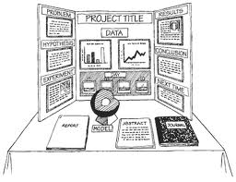
______ 10. CONCLUSION: What did you learn? Did you prove your hypothesis? Why or why not? Do you think there were any errors in your results? What might have caused these errors? If you could complete your investigation in a different way, what would you change and why? What else do you want to learn about your topic? How can you apply what you learned to your own life or to the real world?

